Audio Book Rotation (ABC)
Instructions for Sending and Receiving Rotations

The ABC Rotation takes place every three months. Please use this document as a reference to ensure that you are handling your rotations correctly.

Sending your Rotation on to the next Library
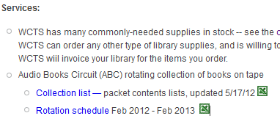
- Consult the 2017 ABC Rotation Schedule to determine who you are sending the items to. If you do not have a saved rotation schedule you can locate one on the Winnefox Extranet under WCTS Services.
- Print out the packet lists for the 4 packets that you will be sending on. Packet lists can also be found on the Extranet.
- Using the Printed list as a guide, pull the titles. It is important to check for worn or damaged cases and missing contents. Forward these items to WCTS with a note detailing what the problem might be. There is space on the packet lists for you to make notations on what is still checked out, may be missing, damaged, or etc. Please make appropriate notations. Include one copy of this packet list with the titles; Send one copy to WCTS.
- Open the “Global Item Modification” wizard in Workflows. This is found under the “Special” Tab.
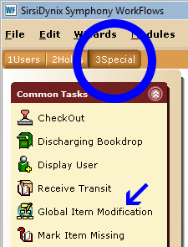
- Change the “Item Library” to the library you will be sending the rotation to.
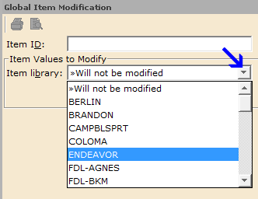
- Scan each title.
- Close the “Global Item Modification” wizard and open “Check Item Status”
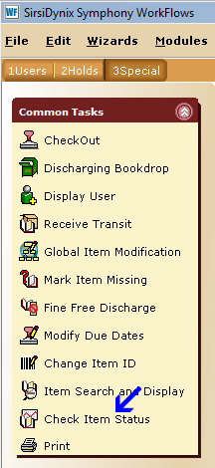
- Scan a title. Once you have scanned a title, a box will open that will show the proposed action. You will have the option to “Put Item in Transit”. Click on this. Once you have done this, you will also have to click OK. These steps must be done individually for each title.
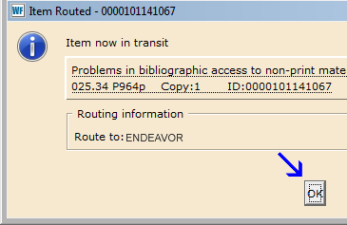
- Pack the titles in the Grey crates labeled ABC. Match the numbers on the titles with the number on the crate. Include an annotated packet list in each crate.
- Label the outside of the crates and put them out for the van delivery

Receiving Rotations:
- Unpack the crates. In addition to the titles you should find an annotated packet list.
- Open the “Receive Transit” wizard in Workflows. Scan each title received.
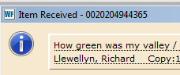
- It is also a good idea to check for any missing contents as you are receiving your titles.

Please report any problems to WCTS

